Physics Stage 3: STAWA Set 4

1 Actually you are but the force of attraction is very small because of the relatively small masses involved.

your mass = 70 kg  mass of building = 10,000 tons  = 1.0 × 107 kg  distance from centre = 100 m | 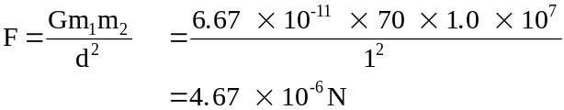

2 a. Yes g, the acceleration due to gravity is slightly less as they are slightly further away from the
centre of the earth.

b. Increases at first due to low crust density and getting closer to centre of earth, then decreases. When underground the miner experiences a force of attraction from all the mass surrounding him. The force depends on the amount of matter in a particular directionand how close he is to that matter. Because the earth's crust is less dense than the earth's interior, near the Earth's surface he gets closer to more matter as he goes deeper. (Increase in density means more matter is packed into less space). So the force down increases. This increase is greater than the decrease due to the matter above him exerting an upward attraction.So near the surface the net force down increases. As the miner decends further there is less and less matter beneath him and more matter above him. So the net force down and hence his weight therefore decreases until it becomes zero at the centre of the earth (theoretically at least).

c. Distance from the centre of the earth ie the earth's radius at the equator is slightly larger than at the poles so g at the poles is slightly larger. Elevation that is distance above sea level has an effect on g for the same reason.
Also variations in the density of the earth's crust. An increase in local density ie more mass per unit volume results in an increase in g in that area. (Ore bodies may be located as a result of gravimetric surveys) Earth tides and terrain also have an effect.

3 A free falling object has no weight. Weight can only be experienced if there is a reaction force pushing on you, in free fall there is no reaction force ∴ no weight.

4 The accelerating force is equal to the weight ie F = mg, since g is constant this force is dependant on the mass.
The acceleration achieved by the object is proportional to the force and inversely proportional to the mass, ie more mass less acceleration

Mathematically | 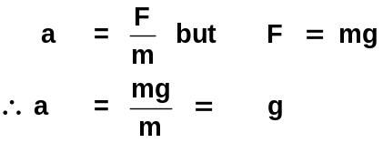

So the acceleration is independent of mass then his weight decreases.

5 Because of the collapse the distance from the centre to the new surface is much smaller than the distance from the centre of the star to the original surface. If the radius is reduced by a factor of 106 then the gravitational force is increased by a factor of 1012. At a distance from the black hole equal to the stars original radius the gravitational force would be the same as it was at the surface of the original star.

6
g = 9.8 m s-2  rE = 6.38 × 106 m  G = 6.67 × 10-11 N m2 kg-2  mE = ? | 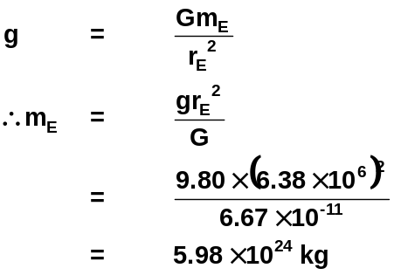
Mass of Earth = 5.98 ×1024 kg

7
F= Gm₁ m₂/r²
F = 1.72 x 10⁻⁶ N

Mass of Earth = 5.98 ×1024 kg

8 a. Since mass is constant if

g = 4.9 m s-2  r = ?  mE = 5.98 × 1024 kg  G = 6.67 × 10-11 N m2 kg-2 | 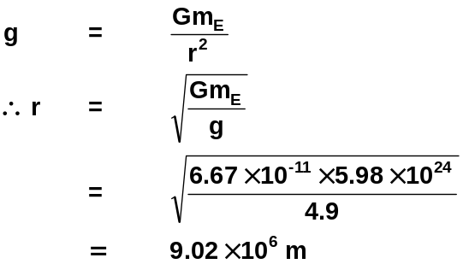  Height above  Earth's surface = 9.02 × 106 - 6.38 × 106  = 2.64 × 106 m

b.
G = 6.67 × 10-11 N m2 kg-2  mE = 5.98 × 1024 kg  r = rE + height  = 6.38 × 106 + 610 × 103m  = 6.99 × 106m | 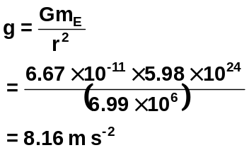
Space shuttle experiences an acceleration of 8.16 m s-2 towards the centre of the earth

c. 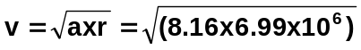
v = 7552
v = 7.55 x 10³ ms⁻¹

9
F = 2.03 × 1020 N  mm = 7.34 × 1022 kg  mE = 5.98 × 1024 kg  G = 6.67 × 10-11 N m2 kg-2  r = ? | 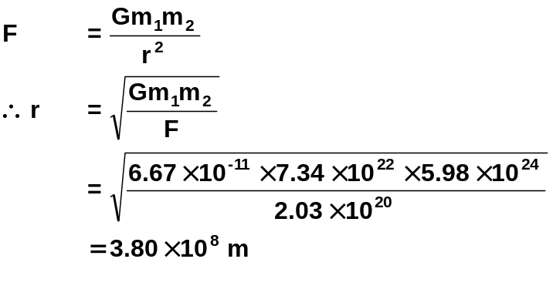
The moon is 3.80 × 108 m from the Earth

10
mN = 16.6 mE  rN = 3.89 rE  gE = 9.80 m s-2 | 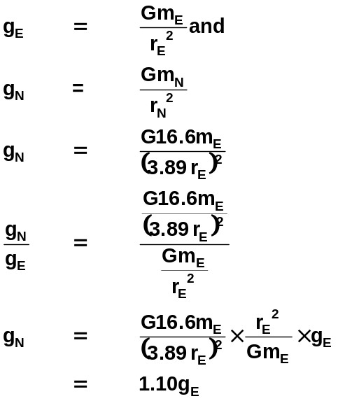
Acceleration due to gravity on surface of Neptune is 1.10 times the acceleration due to gravity on earth's surface

11
a. The force of attraction is at right angles to the direction of motion. There is no component in the direction of motion hence no acceleration and no change in speed.

b.
mE = 5.98 × 1024 kg  mm = 7.34 × 1022 kg  ms = 1.99 × 1030 kg  dEM = 3.80 × 108 m  dSM = 1.49 × 1011 - 3.80 × 108 m  = 1.4862 × 1011 m  G = 6.67 × 10-11 N m2 kg-2 | 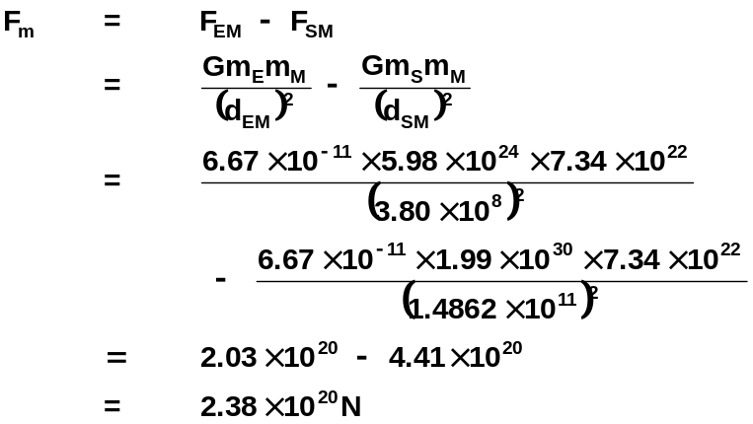

Net force on moon is 2.38 × 1020 N towards the sun

12 The period of the communications satellite is much longer than that of Skylab.

for stable orbit | 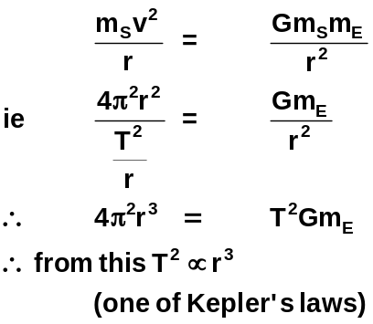

ie as the radius increases so does the period

13 a It would continue to accelerate towards the earth and because its tangential velocity has been reduced to 0 it would fall towards the centre of the earth.

b Their tangential velocity is large enough so they continue to fall around the earth. Their orbital period is the same as the earth's rotational period.

14 a The earth rotates from west to east. A rocket (and everything else) on the earth's surface already has the same tangential velocity in an easterly direction. To achieve orbital velocity less energy is needed if the rocket already has some velocity ie 464 m s-1 or 1670 km h-1 at the equator.

T = 24 × 60 × 60 s  rE = 6.38 × 106 m | 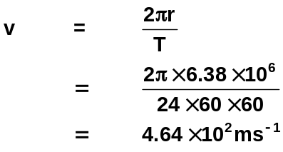

b The tangential velocity at the equator is a maximum of any place on the earth's surface. This is because the circumference of the path followed by objects on the surface is greatest at the equator.

15 Reduce the tangential velocity of the capsule.

16 As the satellite moves closer to the earth it looses potential energy since energy is conserved there must be an increase in kinetic energy so an increase in speed results. (Also conservation of angular momentum)

17 They experience weightlessness as they are in continuous free fall. There is no reaction force to their weight force therefore they feel no weight and need to be strapped into their seats.

18
r = 6.38 × 106 + 550 × 103  = 6.93 × 103 m  G = 6.67 × 10-11 N m2 kg-2  mE = 5.98 × 1024 kg | 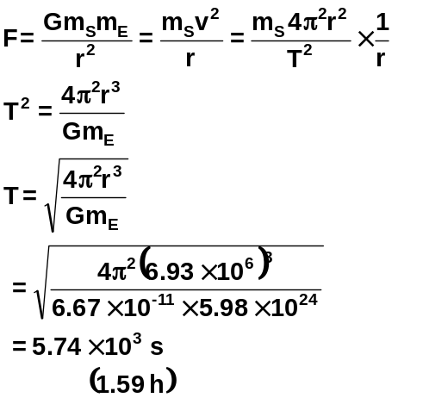
Period is 5.74 × 103 s

19
r = 6.71 × 108 m  T = 3.07 × 105 s | 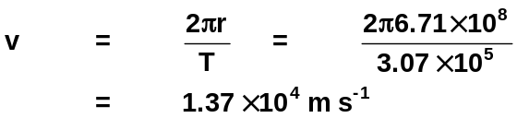
Orbital velocity = 1.37 × 104 m s-1

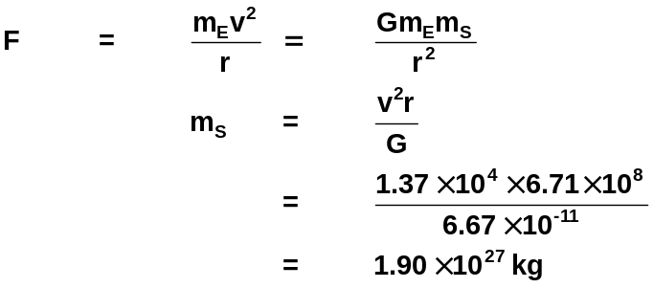

Mass of Jupiter = 1.90 × 1027 kg

20
r = 2.02 × 107 + 6.38 × 106 = 2.66 × 107 m  T = 12 h = 12 × 60 × 60 s = 4.32 × 104 s  G = 6.67 × 10-11 N m2 kg-2 | 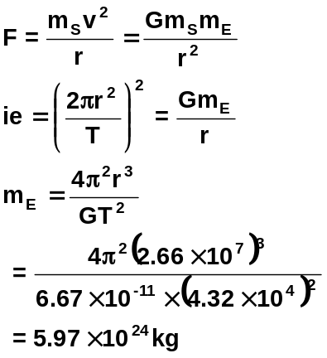

Mass of Earth = 5.97 × 1024 kg

21
T = 24 × 60 × 60 s  mE = 5.98 × 1024 kg  G = 6.67 × 10-11 N m2 kg-2 | 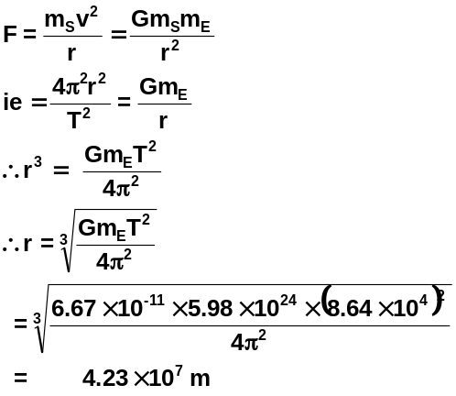

Height above Earth = 4.23 × 107 - 6.38 × 106 = 3.59 × 107 m

22
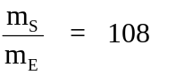  TT = 14 days  TM = 27.3 days | From question 13  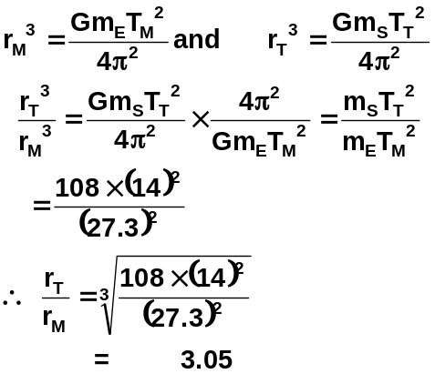

Ratio of Titan's orbital radius to that of the moon is 3.05

23
mM = 3.30 × 1023 kg  rP = 4.60 × 1010 m  rA = 6.90 × 1010 m  G = 6.67 × 10-11 N m2 kg-2  mS = 1.99 × 1030 kg | 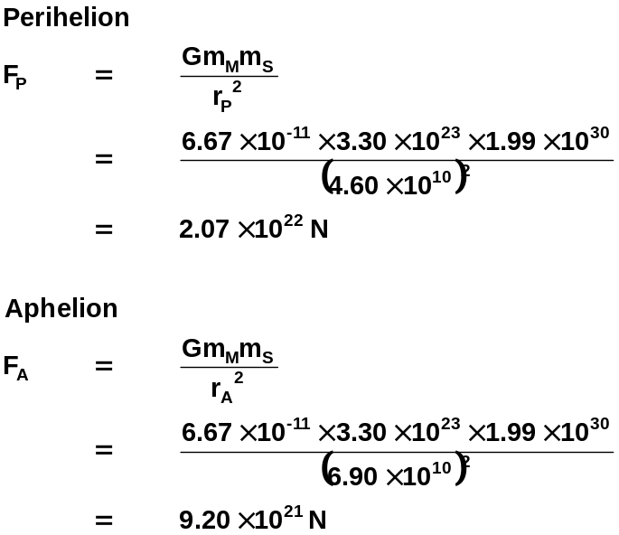

b The velocity changes throughout the orbit reaching a maximum at Perihelion and minimum at Aphelion

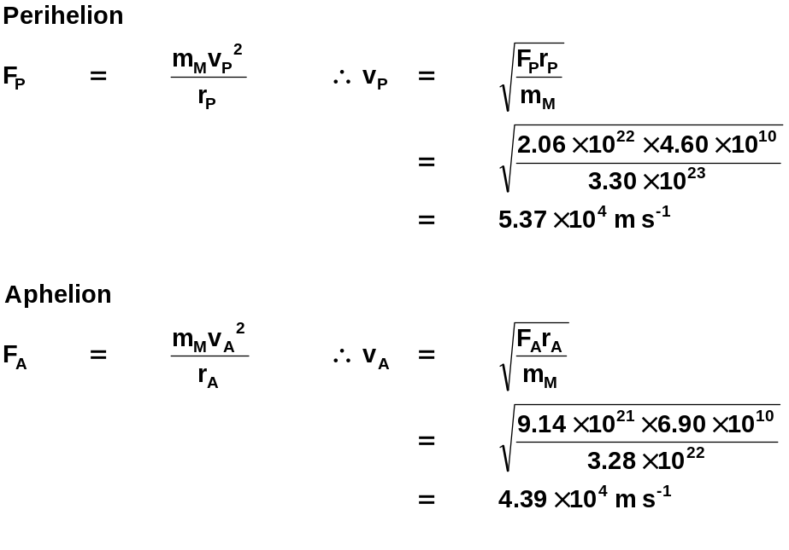

c As Mercury approaches Perihelion it looses potential energy and gains an equal amount of kinetic energy so its speed increases. As it approaches Aphelion Mercury gains potential energy and looses an equal amount of kinetic energy.

At all times Ek + Ep is constant.

